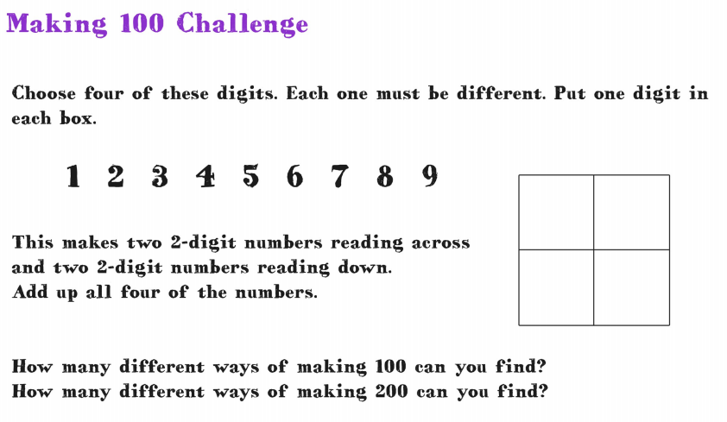

2, 1, 3, 8

21, 38, 23, 18

|  |  |
| --- | --- |
| 2 | 1 |
| 3 | 8 |